ROTARY PENDULUM MODELING

Topics Covered

• Interact with the QUANSER@ QUBEServo 2 Rotary Pendulum system.

• Configure sensor and actuator gains to match model conventions.

Prerequisites

• Hardware Interfacing laboratory experiment.
1 Background

The rotary pendulum system, also known as the Furuta Pendulum, is a classic system often used to teach modeling and control in physics and engineering. The convention used for the modeling of the QUBEServo 2 rotary pendulum is shown in Figure 1.1.

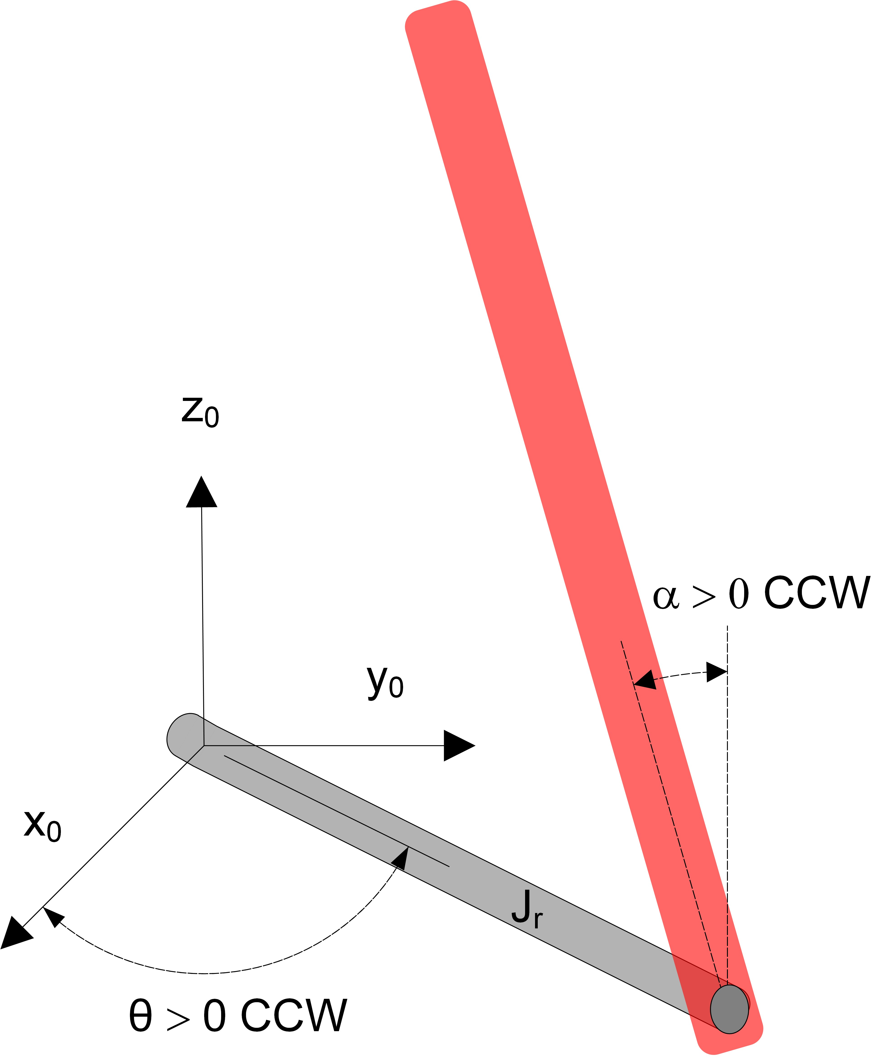
Figure 1.1: Model conventions of rotary pendulum

The rotary arm, which is attached to the motor pivot, is denoted by the variable θ and the pendulum angle, attached to the end of the rotary arm, is denoted by α. Note the following conventions:

• Angle α is defined as the inverted pendulum angle, i.e. the angle with respect to the upright vertical position where α = 0 means the pendulum is perfectly upright. It is expressed mathematically using

α = αf ull mod 2π − π. (1.1)

where αf ull is the pendulum angle measured by the encoder, i.e. the continuous angle measurement defined as zero when pendulum is in the downward configuration.

• Both angles are defined as positive when rotated in the counterclockwise (CCW) direction.

• When a positive voltage is applied to the motor, the rotary arm moves in the positive CCW direction.

The goal is to design a system model that follows these conventions. The Hardware Interfacing laboratory experiment introduced the DC motor and encoders on the QUBEServo 2 system. The pendulum angle is also measured using an encoder.
2 In-Lab Exercises

In this lab, we will make a SIMULINK@ model using QLABS@ blocks to drive to the dc motor and measure both the rotary arm and pendulum angles similarly as shown in Figure 2.1.

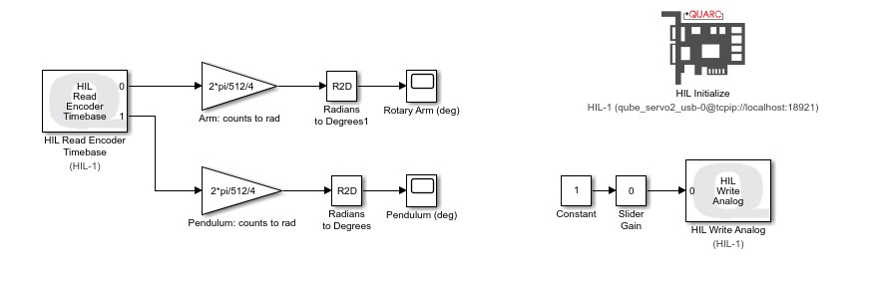

Figure 2.1: SIMULINK@ model used with QLABS@ to drive motor and read angles on QUBEServo 2 Rotary Pendulum system

1. Using the SIMULINK@ model you made in the Hardware Interfacing laboratory experiment, do the following:

• Configure the HIL Read Encoder Timebase block to read from both channels #0 and #1. The pendulum is measured on channel #1.
• Setup the encoder gains on each channel to read the angles in radians (instead of degrees as in the lab).
• Connect the the measured angles to scopes, but display them in degrees. You can do this using the Simulink Extras | Transformation blocks or just by adding another Gain block that converts radians to degrees.
• If desired, add a Slider Gain block between the Constant and Analog Output block. Make sure the Constant
source block is set to 1 in this case.

2. Run the QLABS@ software.

3. Load the QUBEServo 2 Pendulum Virtual Experiment by going to QUBE 2 Pendulum | Pendulum Workspace
virtual system.

4. Run the Simulink model.

5. Rotate the pendulum counterclockwise by clicking on the Lift pendulum button in QLABS@ . Examine the response in the Pendulum scope as the pendulum rotates upwards. An example response is shown in Figure 2.2. Does the measured angle follow the modeling conventions given in Section 1? Stop the Simulink model once you obtain a representative response.
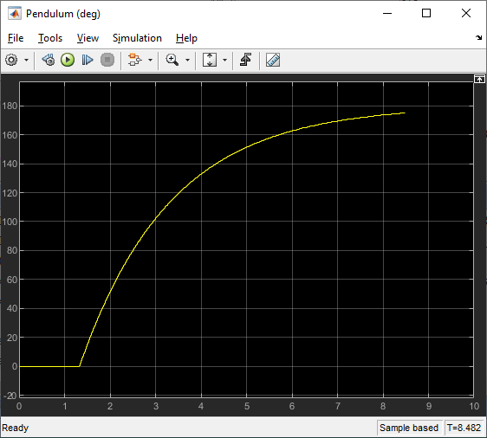

Figure 2.2: Measured pendulum angle

6. Apply a small voltage (e.g. 0.5 V) to the motor by changing the value of the Slider Gain block connected to HIL Analog Output block, shown in Figure 2.1, and examine the rotary arm on the virtual QUBEServo 2. Stop the Simulink model. Does the rotary arm on the virtual QUBEServo 2 adhere to the modeling convention?

7. Modify the Simulink model such that the measured rotary arm and pendulum angles and applied voltage, i.e. response of rotary arm on virtual QUBEServo 2, follow the modeling conventions. Briefly list any changes made.
Hint: Make sure to confirm that both the rotary arm on the virtual QUBEServo 2 moves in the correct direction when a positive voltage is applied and that the measured angles in the scopes follow the modeling conventions.

8. Add modulus and bias blocks, as shown in Figure 2.3, to measure inverted pendulum angle, defined as
Equation 1.1.

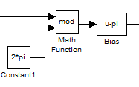

Figure 2.3: SIMULINK@ modulus and bias blocks

9. Make sure the pendulum is hanging in the downward position and lies motionless before starting the controller.

10. Rotate the pendulum to the upright vertical position and ensure the angle is measured correctly and it follows the model conventions shown in Figure 1.1. Capture the response of the pendulum being raise to the inverted position. Explain what the bias and modulus functions do?

11. Stop the Simulink model.

© 2021 Quanser Inc., All rights reserved.

Quanser Inc.
119 Spy Court Markham, Ontario L3R 5H6
Canada info@quanser.com Phone: 19059403575
Fax: 19059403576

Printed in Markham, Ontario.

For more information on the solutions Quanser Inc. offers, please visit the web site at:
http://www.quanser.com

This document and the software described in it are provided subject to a license agreement. Neither the software nor this document may be used or copied except as specified under the terms of that license agreement. Quanser Inc. grants the following rights: a) The right to reproduce the work, to incorporate the work into one or more collections, and to reproduce the work as incorporated in the collections, b) to create and reproduce adaptations provided reasonable steps are taken to clearly identify the changes that were made to the original work, c) to distribute and publically perform the work including as incorporated in collections, and d) to distribute and publicly perform adaptations. The above rights may be exercised in all media and formats whether now known or hereafter devised. These rights are granted subject to and limited by the following restrictions: a) You may not exercise any of the rights granted to You in above in any manner that is primarily intended for or directed toward commercial advantage or private monetary compensation, and b) You must keep intact all copyright notices for the Work and provide the name Quanser Inc. for attribution. These restrictions may not be waved without express prior written permission of Quanser Inc.

